USER REPORT
The FinCoop Cooperative Financial Transaction Management System is a Python-based application that helps a cooperative society manage members, financial transactions, and loans. The system allows users to register members, make deposits and withdrawals, process loans, search transactions, undo recent transactions, and generate reports.

System Requirements
Hardware Requirements
- Computer or laptop
- 4 GB RAM or more
- Keyboard and monitor
Software Requirements
- Windows 10 or Windows 11
- Python 3.10 or later
- Visual Studio Code (or any Python IDE)

Starting the System
- Open the project folder in Visual Studio Code.
- Open the Terminal.
- Run the program using:
python fincoop.py
- The main menu will appear.

Main Menu
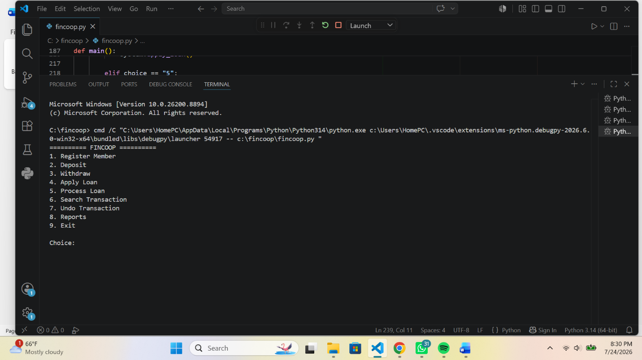
User Guide (Steps)
Register a Member
- Select 1. Register Member.
- Enter the Member ID.
- Enter the Member Name.
- Wait for the confirmation message "Member registered successfully."
Deposit Money
- Select 2. Deposit.
- Enter the Member ID.
- Enter the Deposit Amount.
- Enter the Transaction ID.
- Wait for the confirmation message "Deposit successful."
Withdraw Money
- Select 3. Withdraw.
- Enter the Member ID.
- Enter the Withdrawal Amount.
- Enter the Transaction ID.
- Wait for the confirmation message "Withdrawal successful."
Apply for a Loan
- Select 4. Apply Loan.
- Enter the Member ID.
- Enter the Loan Amount.
- Enter the Loan Priority.
- Wait for the confirmation message "Loan application submitted."
Process a Loan
- Select 5. Process Loan.
- The system processes the loan with the highest priority.
- The approved loan details are displayed.
Search for a Transaction
- Select 6. Search Transaction.
- Enter the Transaction ID.
- View the transaction details displayed by the system.
Undo a Transaction
- Select 7. Undo Transaction.
- The system reverses the most recent transaction.
- A confirmation message is displayed.
Generate Reports
- Select 8. Reports.
- View the list of registered members and their account balances.
Exit the System
- Select 9. Exit.
- The application closes successfully
Conclusion
The FinCoop Cooperative Financial Transaction Management System provides a simple and efficient way to manage cooperative financial activities. It enables users to register members, process transactions, manage loans, and generate reports while ensuring data is organized and processed efficiently.

